08 September 2022

# Crime Data analysis using Pig

1. To find the total number of crimes which occurred in all the states in the year 2006.

2. Calculate the number of females (age between 18-30 years) who were victims in different crimes in different states.

4. Find crime wise which state is having highest count.

5. Find the maximum dowry deaths happened in which year and in which state.

6. Calculate the number of males (age between 45-60 years) who were victims in “Kidnapping and

abduction” in different states.

Q1.

Output:-





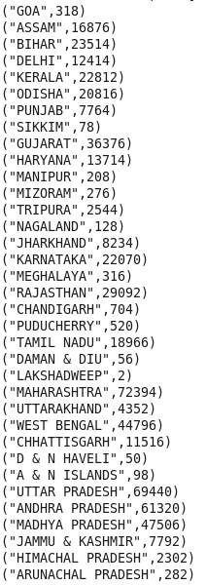

Q2.

Output:

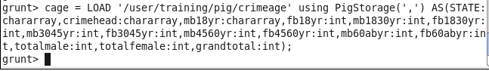



Result:-

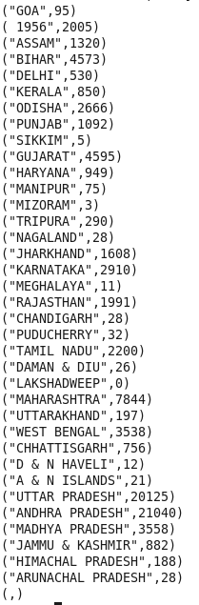

Q3

Output:-







Result:-



Q4

Output:-



Result:-

